var change = document.getElementsByClassName('list')[2];
change.innerHTML = "Angela";

querySelector
Uses css selector to identify the target
document.querySelector('.list a').style.color = "red";
document.querySelector('button').style.backgroundColor = "yellow";

// document.querySelector("h1").classList.add("huge");
// document.querySelector("h1").classList.remove("huge");
document.querySelector("h1").classList.toggle("huge");

innerHTML vs textContent
document.querySelector("h1").innerHTML;
// Before: <h1><strong>Hello</strong></h1>
// After: <strong>Hello</strong>

document.querySelector("h1").textContent;
// Before: <h1><strong>Hello</strong></h1>
// After: Hello

classList
Displays the list of classess in a tag.
document.querySelector("h1").classList;
// Output: DOMTokenList ["huge", value: "huge"]
// since class "huge" is on toggle, it will alternate between:
// DOMTokenList ["huge", value: "huge"]
// DOMTokenList [value: ""]

document.querySelector("a");
// Output: <a href="https://www.google.com">Google</a>
document.querySelector("a").attributes;
// Output: NamedNodeMap {0: href, 1: style, href: href, style: style, length: 2}
document.querySelector("a").getAttribute("href");
// Output: "https://www.google.com"
document.querySelector("a").setAttribute("href", "https://ph.yahoo.com/?p=us");
// Output: undefined but this is ok.

Higher Order Functions
A function that takes another function as an argument/parameter or returns a function.
function add(num1, num2) {
return num1 + num2;
}

function subtract(num1, num2) {
return num1 - num2;
}

function multiply(num1, num2) {
return num1 * num2;
}

function divide(num1, num2) {
return num1 / num2;
}

function calculator (num1, num2, operation) {
return operation(num1, num2);
}

//in the console, type in "debugger;" and add the function/code you want to trace.

Play Sounds on the Website
let drums = document.querySelectorAll(".drum").length;

for (let i=0; i < drums; i++) {
// document.querySelectorAll(".drum") grabs all the elements with the class(denoted by a period in css selectors) “drum”.
// each element identified (due to the loop) by the querySelectorAll will be added an event listener (addEventListener) so when the element is “click”-ed by the user, the function makeSounds will be executed.
document.querySelectorAll(".drum")[i].addEventListener("click", makeSounds);

}

function makeSounds () {
let drumLetter = this.innerHTML;
let drumSound = "tom-1";
switch (drumLetter) {
case 'w':
drumSound = "tom-1";
break;
case 'a':
drumSound = "tom-2";
break;
case 's':
drumSound = "tom-3";
break;
case 'd':
drumSound = "tom-4";
break;
case 'j':
drumSound = "snare";
break;
case 'k':
drumSound = "crash";
break;
case 'l':
drumSound = "kick-bass";
break;
default:
console.log("Drum sound does not exist");
}
var audio = new Audio("sounds/tom-1.mp3");
audio.play();
}

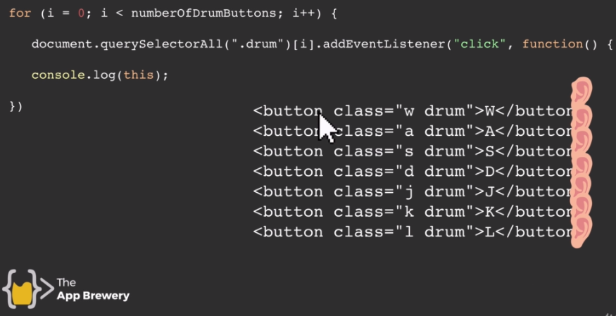

JavaScript Objects
Different objects have different properties/attributes/methods.

var housekeeper = {
name: "Jane",
age: 20,
gender: "Female",
responsibility: ["bathroom", "bedrooms"] // An array of responsibility
clean: function() {
alert("Cleaning in progress");
}
}

Constructor Functions
Function name should have its first letter capitalized for each word.
For example instead of “houseKeeper”, we should name it as “HouseKeeper” as an indication that it is a constructor function.

function HouseKeeper (name, age, gender, responsibility) {
this.name = name;
this.age = age;
this.gender = gender;
this.responsibility = responsibility;
}

Initialize an Object using a Constructor Function
var hk1 = new HouseKeeper("Angela", 23, "Female", ["bathroom", veranda"]);

Callback Functions
A function that gets passed in as an input which allows the user to wait for something to finish happening.
Example: waiting for a click event.

